Step 0 Intake + Interview Filing Status, Dependency

Interview Notes: (See also: General Notes)
- The Conways moved from an apartment in Hoboken to an apartment in Jersey City on September 30 of the current tax year. They paid $2,000/month rent in Hoboken through September and $1,000/month in Jersey City starting in October.
- Charles lost his job in August of the current tax year and collected unemployment for the balance of the year.
- In January of the tax year the Conways purchased a 50” LCD TV from Amazon.com and did not pay sales tax on the purchase amount of $1,500.00. The sales tax amount (6.875% in 2017) would have been $103.13
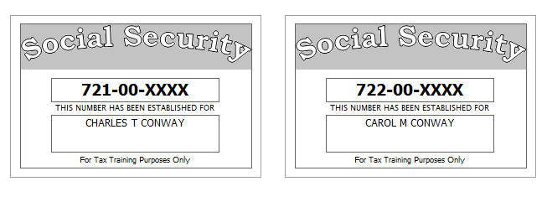

Step 1 Basic Information

TP Form / Note | TS Screen | Notes
SS Card | Start a New 2017 Tax Return  Available Taxpayer Profiles | Ignore the Profiles  Select “Enter Social Security Number” at the bottom of the screen  Enter the TP SSN twice and “Start Return”
Intake Sheet | What is your filing Status? | Answer: Filing Status: Married filing joint  Continue
SS Card  Intake Sheet  G-Note 2  I- Note 1 | Personal Information  Taxpayer Information  Spouse Information  Address & Phone Number | TS: Enter all information using “Caps Lock”  Hint: Use Name and SSN from SS card. (Not Intake Sheet)  Hint: SSN format YYY-00-0752  TS: Birth date can be entered using drop down menu or filling in the field.  TS: Check any of the “Check here” questions that apply –  TS: Spouses last name auto populates when field is selected. Change if required.  TS: Enter Zip code- TaxSlayer fills in city and state. Correct if required  TS: Enter New Jersey as the Resident State  TS: Select Continue
Intake Sheet  G-Note 2, 3 | New Jersey Return | Hint: Begin NJ Checklist  TS: Select Municipality from drop down menu (Listed by county).  Answer: Jersey City is in Hudson County. Start typing Hudson to quickly scroll down.  TS: Answer question regarding dependent Health Insurance. There are no dependents, just skip the question.  TS: Select Yes or No for the Gubernatorial Election Fund. See Intake Sheet page 3 and General Note 3. No for TP and Spouse  TS: Five Digit Pin for TP and SP is automatically selected  TS: Select Continue
Intake Sheet. | Dependents/ Qualifying Person  Do you have any Dependents or Qualifying Person(s) to claim on your return? | TS: Answer is “No”.

Federal AGI: 0 Federal Refund: 0 NJ Refund Amount: 0
Step 2 W-2 Vampire Engineering
W-2  Vampire Engineering | Let’s look at the money you earned Enter Myself  Income  Wages & Salaries Form W-2 - Begin | Hint: Charles Conway W-2  Hint: Make corrections so that information matches the information on the W-2. Correct the address of Employee in TaxSlayer to match paper W-2. Correct address for this W-2.  Hint: Use EIN 72-9000752  Hint: If the name and address of the employer come up after inputting the employer Identification Number, check that the information is correct  Hint: Check boxes 3-7 for correct entries  Hint: Always round up for amounts ending in --.50  Hint: Box 12 Use dropdown to select correct code  Hint: Box 13- Retirement Plan should be checked  Hint: Box 14 NJ Codes are selected from drop down menu. All other entries in box 14 are lumped under “Other”.  Hint: If NJ State EIN auto populates, check to be sure it is correct  Hint: Correct NJ wages  TS: Click Save & Enter Another  NJ warning if applicable - Continue

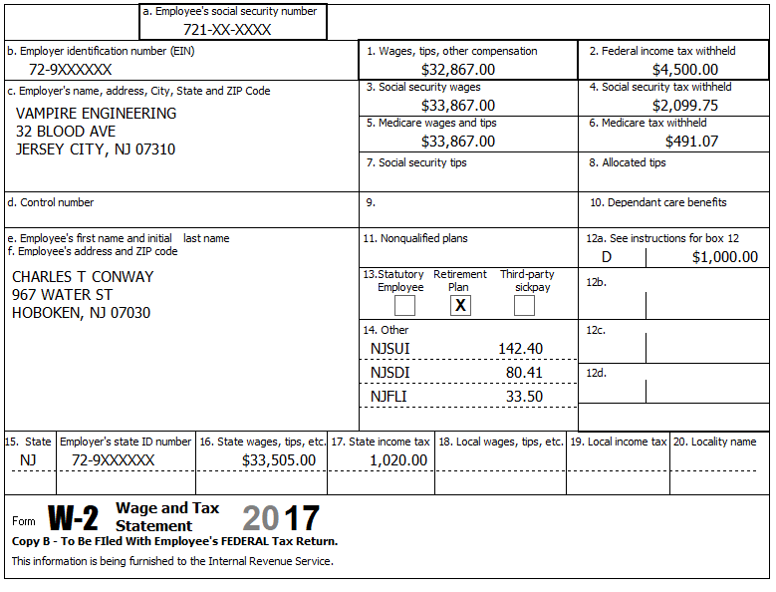

Federal AGI: 32,867 Federal Refund: 3,792 NJ Refund Amount: 538
Step 3 W-2 Smart Kids Charter School

W-2 Smart Kids Charter School | Add W-2 Statement | Hint: W-2 is for Carol  Hint: Make corrections so that information matches the information on the paper W-2  Hint: Use EIN: 72-8000752  Hint: If the name and address of the employer come up after inputting the employer Identification Number, check that the information is correct  Hint: Always round up for amounts ending in --.50  Hint: Box 14 NJ Codes are selected from drop down menu. All other entries in box 14 are lumped under “Other”  Hint: If NJ State EIN auto populates, check to be sure it is correct  TS: Click continue NJ warning if applicable  TS: Click Continue

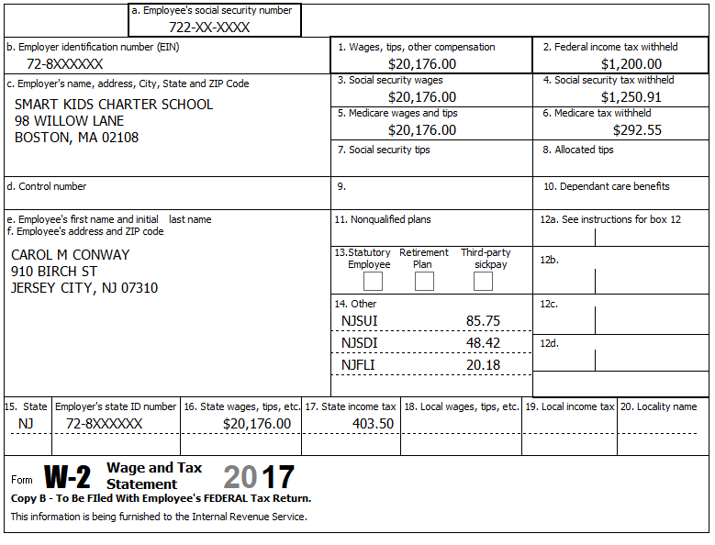

Federal AGI: 53,043 Federal Refund: 1,899 NJ Refund Amount: 578
Step 4 Interest 1099-INT

TP Form / Note | TS Screen | Notes
1099-INT  PNC Bank | Federal Section - Income  Interest Income, Form 1099-INT/ 1099-DIV- Begin  Interest or Dividend Income -Begin  Interest Income, Form 1099-INT,Form 1099-OID…..  Continue | Hint: Select for Taxpayer  Enter values that apply  Continue – Back to Income

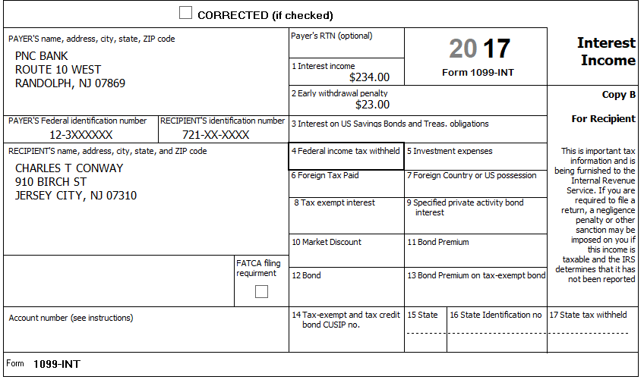

Federal AGI: 53,254 Federal Refund: 1,861 NJ Refund Amount: 573
Step 5 Unemployment 1099-G

TP Form / Note | TS Screen | Notes
1099-G  NJ Dep of Labor | Left Menu- Federal Section - Income  UnemploymentCompensation Form 1099-G Box 1 – Begin  Add or Edit a 1099-G - Begin | TS: This 1099G worksheet is for the: Charles Conway  Hint: Phone number not required  Hint: State information not required  Continue

Charles lost his job in August of the current tax year and collected unemployment for the balance of the year.

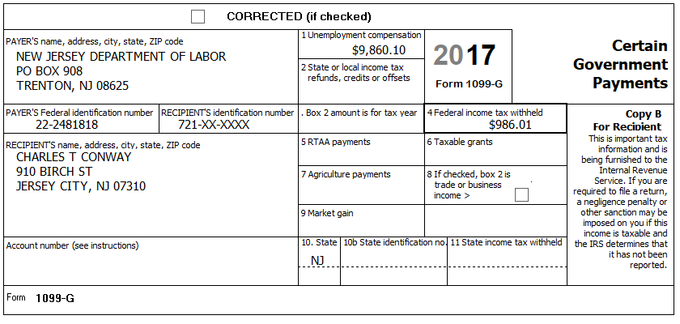

Federal AGI: 63,114 Federal Refund: 1,270 NJ Refund Amount: 573
Step 6 Federal Deductions, Adjustments & Credits
TP Form / Note | TS Screen | Notes
 | Left Menu - Federal Section -Deductions  Enter Myself  Itemized Deductions - Begin  Taxes You Paid - Begin | Go to the Add Sales Tax Worksheet and enter NJ, Zip Code, and 365 days living in the state  Continue back to Deductions

Federal AGI: 63,114 Federal Refund: 1,270 NJ Refund Amount: 573
Step 7 Compare Standard vs Itemized Deductions

TP Form / Note | TS Screen | Notes
 | Federal Section  Deductions  Enter Myself  Compare Deductions - Begin | Check to see if using itemized or standard deductions.  Itemized = 1,834  Std = 12,700  Hint: You can view Schedule A (Itemized Deductions) by clicking on the Print Icon next to Itemized Deductions in the Deductions Menu.  Continue

Federal AGI: 63,114 Federal Refund: 1,270 NJ Refund Amount: 573

Step 8 Health Insurance

TP Form / Note | TS Screen | Notes
G-Note 2 | Left Menu -Health Insurance  Start Questionnaire | Answer questions in the Health Insurance Section

Every person on the return had health insurance that met Minimum Essential Coverage rules for the entire year. They did not purchase it through the marketplace.

Federal AGI: 63,114 Federal Refund: 1,270 NJ Refund Amount: 573
Step 9 New Jersey Return

TP Form / Note | TS Screen | Notes
I-Note 1 & 3  G-Note 2,3 | State Return –Edit  Basic Information -Edit  Credits  - ` Property Tax/Deduction  Tax  - Use Tax on Out of State Purchase | Hint: Use the NJ Checklist to enter NJ items  HINT: Check Basic Information – Default values will not appear as selected  Hint: Use scratch pad at TP4F to determine the proper value for Property Tax Paid  Hint: Property Taxes Paid = (rent*.18). [(2000x9)+ (1000x3)]x.18= 3,780  Hint: Taxpayer meets Property Tax Eligibility Requirements  Hint: Use scratch pad to determine Use tax on TV purchase = 103.  Hint: Taxpayer was not a homeowner in 2017.  Continue back to the beginning of the State Return
The Conways moved from an apartment in Hoboken to an apartment in Jersey City on September 30 of the current tax year. They paid $2,000/month rent in Hoboken through September and $1,000/month in Jersey City starting in October.
In January of the tax year the Conways purchased a 50” LCD TV from Amazon.com and did not pay sales tax on the purchase amount of $1,500.00. The sales tax amount (6.875% in 2017) would have been $103.13

Federal AGI: 63,114 Federal Refund: 1,270 NJ Refund Amount: 549

Step 10 Prepare for e-file

Intake Sheet  Supplemental Intake Sheet  G Note 5 | Left Menu – e-file – | TS – Clear up any diagnostic messages (if any)  TS: Select Federal Return Type “E:file: Direct Deposit”  Next  TS: No entries in Fees section except for Client email address  TS – Pin numbers for e-file are automatically selected  Next  TS: Select State Refund Type “E:file: Direct Deposit”  Next  TS: Enter Bank Information – Name of Bank not required. Deposit amount is required. Click “PULL REFUND”  Next  TS: Skip Third Party Designee Info  Next  TS: Consent to Disclose Tax Return Information – Check DENY and enter 5 digit pin ( any 5 digit number) and date for TP and SP  Next  TS – Questions – Answer questions from Intake sheet Part VII, lines 5.6 and 7  Next  TS: Skip TP ID Information Screen  Save  You are Done

They want to handle any state refund / amount due like their federal refund / amount due

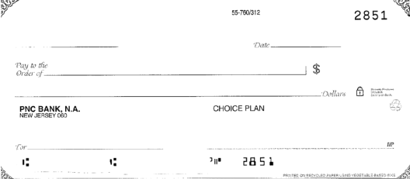
Charles T. & Carol M. Conway
910 Birch Street
Jersey City, NJ 07310
031207607
12345678901

Federal AGI: 63,114 Federal Refund: 1,270 NJ Refund Amount: 549

